Part I - The Final Report

Section 1 - Database Description

ER Model

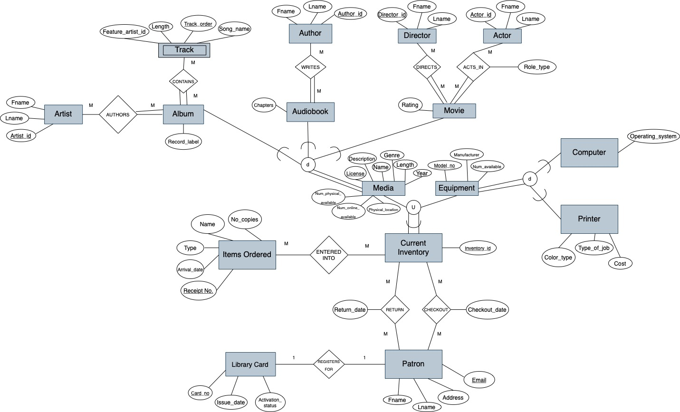

Relational Schema
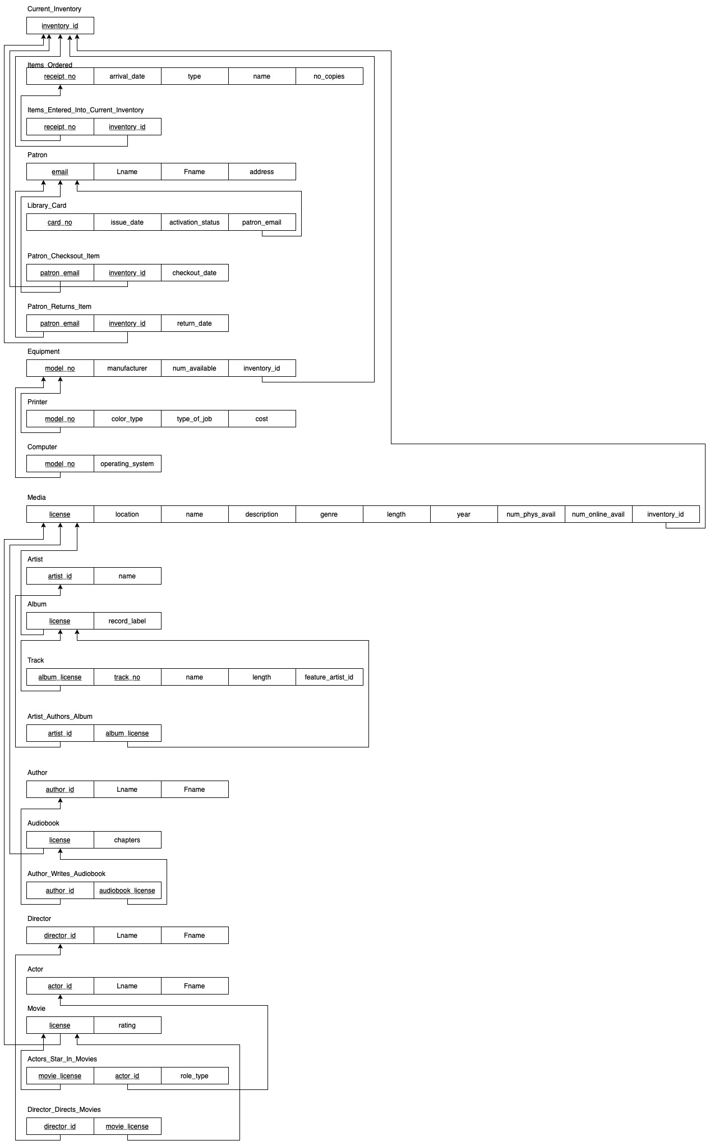
Level of Normalization of Each Table

Current_Inventory
This table is in BCNF since no functional dependencies exist (inventory_id is the only attribute).

Items_Ordered
This table is in BCNF because the combination of all attributes are fully functionally dependent on receipt_no, and no other superkeys exist.

Items_Entered_Into_Current_Inventory
This table is in BCNF because receipt_no and inventory_id are both superkeys, and no other attributes exist.

Patron
This table is in BCNF because the combination of all attributes are fully functionally dependent on email, and no other superkeys exist.

Library_Card
This table is in BCNF because the combination of all attributes are fully functionally dependent on card_no, and no other superkeys exist.

Patron_Checksout_Item
This table is in BCNF since no functional dependencies exist.

Patron_Returns_Item
This table is in BCNF since no functional dependencies exist.

Equipment
This table is in BCNF because the combination of all attributes are fully functionally dependent on model_no, and no other superkeys exist.

Printer
This table is in BCNF because the combination of all attributes are fully functionally dependent on model_no, and no other superkeys exist.

Computer
This table is in BCNF because the combination of all attributes are fully functionally dependent on model_no, and no other superkeys exist.

Media
This table is in BCNF because the combination of all attributes are fully functionally dependent on license and location, and no other superkeys exist.

Artist
This table is in BCNF because name is fully functionally dependent on artist_id, and no other attributes exist in the table.

Album
This table is in BCNF because record_label is fully functionally dependent on license, and no other attributes exist in the table.
Track
This table is in BCNF because the combination of all attributes are fully functionally dependent on album_license and track_no, and no other superkeys exist.

Artist_Authors_Album
This table is in BCNF since no functional dependencies exist.

Author
This table is in BCNF because the combination of all attributes are fully functionally dependent on author_id, and no other superkeys exist.

Audiobook
This table is in BCNF because chapters are fully functionally dependent on license, and no other attributes exist in the table.

Author_Writes_Audiobook
This table is in BCNF since no functional dependencies exist.

Director
This table is in BCNF because the combination of all attributes are fully functionally dependent on director_id, and no other superkeys exist.

Actor
This table is in BCNF because the combination of all attributes are fully functionally dependent on actor_id, and no other superkeys exist.

Movie
This table is in BCNF because rating is fully functionally dependent on license, and no other attributes exist in the table.

Actors_Star_In_Movies
This table is in BCNF because role_type is fully functionally dependent on the combination of movie_license and actor_id, and no other attributes exist in the table.

Director_Directs_Movies
This table is in BCNF since no functional dependencies exist.

Indexes

- CREATE INDEX mediaByYear ON Media(year);
Many of the queries generated below in the sample queries require either media items released in a certain range of years or a specific year. Indexing media items by year allows for these common queries to be generated faster.
- CREATE INDEX checkoutIndex ON Patron_Checksout_Item(inventory_id);
Patron checkout information, especially pertaining to specific items, is commonly used for queries and indexing by the inventory_id allows for quick joins with a table like Patrons and Current Inventory.
- CREATE INDEX mediaByLength ON Media(length);
The sample queries often compare length of media items by certain aspects (length of all albums by an artist or most watched movies featuring a specific actor) and indexing by Media length makes the access of this data faster, especially considering the size of the Media table.

Views

View 1
i. Creates a table view with all the orders which have arrived on January 1, 2022 and total number of orders. This would be useful because the user could see all of the orders expected on a given day, so they can prepare to receive them.

ii. Create View OrdersFromCBUS AS
T1 <- (Items_Ordered⨝_{Arrival_date = “2022-01-01”} Current_Inventory)
T2 <- π(No_Copies, Name, Type, Arrival_Date, Receipt_No, ℱ_{COUNT} Arrival_Date)(T1)
ρ(No_Copies, Name, Type, Arrival_Date, Receipt_No, Total_Orders)(T2)

iii. Create view OrdersFromCBUS (Num_Copies, Name, Type, Arrival_Date, Receipt_No, Total_Orders)
As SELECT No_Copies, Name, Type, Arrival_Date, Receipt_No, COUNT(Arrival_Date) AS Total_Orders
From Items_Ordered JOIN Current_Inventory
Where arrival_date= "2022-01-01";

iv. 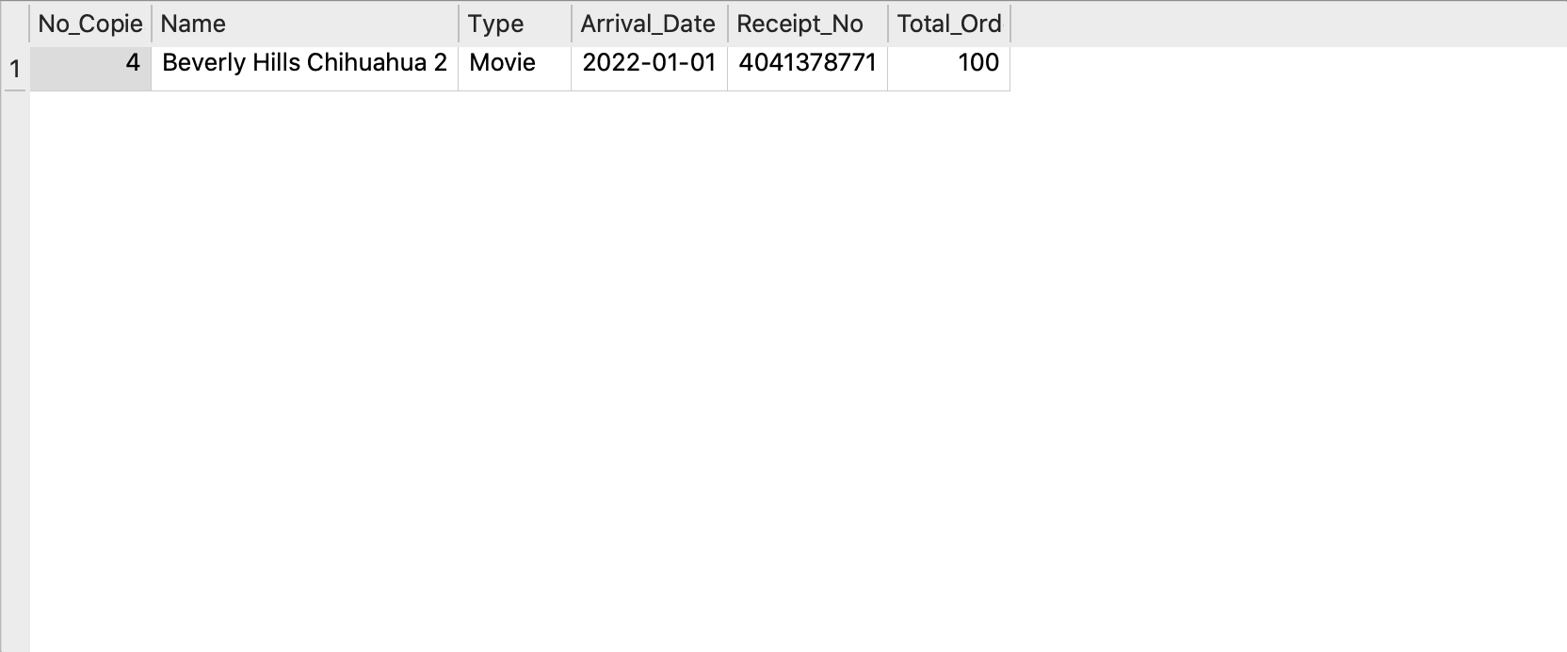

View 2

i. Creates a table view that shows all ordered audiobooks by year and displays the average number of online copies available for them. This would be useful because the user can see if audiobooks are in demand by the patrons and which books need more copies.

ii. T1 <- ((Audiobook⨝_{Type = “Audiobook”}Items_Ordered)⨝ Audiobook.license = Media.license Media)
π_{(Name, Genre, Year, Name}ℱ_{AVG}Num_Online_Avail)(T1)

iii. Create view Audiobooks_Ordered (Name, Genre, Year, Average_Online_Copies_Available)
AS SELECT Media.Name, Genre, Year, AVG(Num_Online_Avail)
FROM Audiobook JOIN Items_Ordered ON Type = "Audiobook", Media
WHERE Media.license = Audiobook.license
GROUP BY Media.Name
ORDER BY Year DESC;

iv. 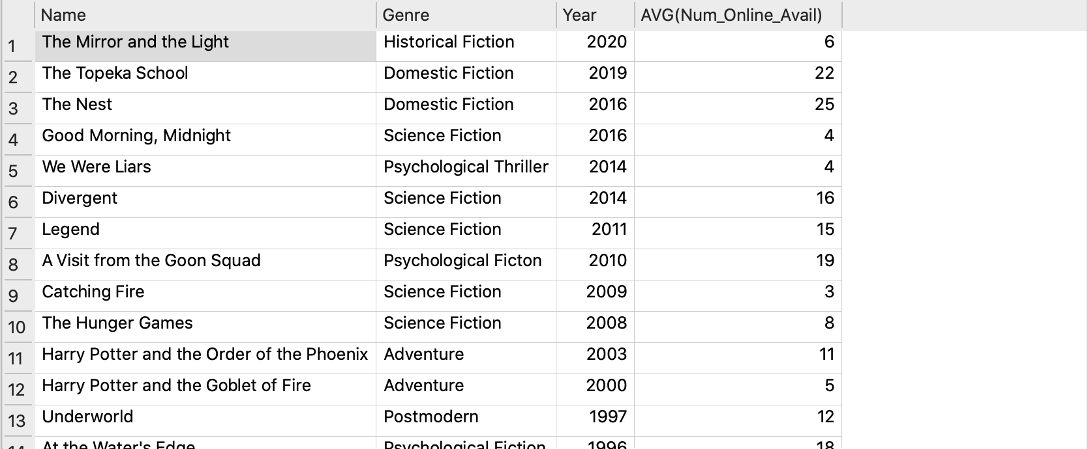
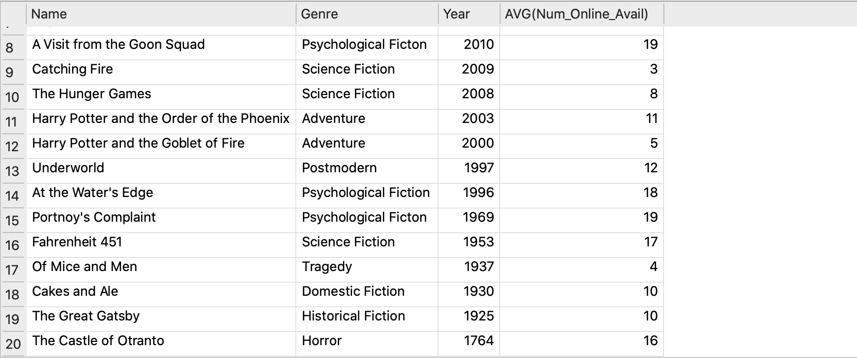

Transactions

- The first transaction is an incrementation of the number of available physical copies and a decrementation of the online copy count for a media item. This is useful because librarians may have to update the counts accordingly when a physical copy was incorrectly entered as an online copy or the library decides to shift online copies to physical.
BEGIN TRANSACTION;
UPDATE OR ROLLBACK Media
SET num_online_avail = num_online_avail - 1
WHERE license = "517482654-5";

UPDATE OR ROLLBACK Media
SET num_phys_avail = num_phys_avail + 1
WHERE license = "517482654-5";
COMMIT;

- Another useful transaction is the updating of multiple media items’ location. This can be because the location of an item may have shifted, causing subsequent locations to change. In this case, the locations should all be updated at once to avoid conflicts.
BEGIN TRANSACTION;
UPDATE OR ROLLBACK Media
SET location = "111.7777"
WHERE license = "111111111-6";

UPDATE OR ROLLBACK Media
SET location = "111.8888"
WHERE license = "111111111-7";

UPDATE OR ROLLBACK Media
SET location = "111.9999"
WHERE license = "111111111-8";

UPDATE OR ROLLBACK Media
SET location = "112.0000"
WHERE license = "111111111-9";
COMMIT;

- The final transaction is to update the count of a media item when a new order comes in. This is useful because when the library orders a new batch of a media item, the count should be updated accordingly. NOTE: The first Insert statement is not necessary, it was added as there was no receipt tuple with the receipt_no = "4075619380", so the insert statement was added to show in this test what would happen if there was an entry with the specified values.
BEGIN TRANSACTION;
INSERT OR ROLLBACK INTO Items_Ordered
VALUES("4075619380", 2022-04-14, "Album", "Are You Experienced?", 3);

INSERT OR ROLLBACK INTO Items_Entered_Into_Current_Inventory
VALUES("4075619380", "123-45-1111");

UPDATE OR ROLLBACK Media
SET num_phys_avail = num_phys_avail + (
SELECT no_copies
FROM Items_Ordered
WHERE receipt_no = "4075619380");
COMMIT;

Section 2 - User Manual

Real World Descriptions of Each Table

Current_Inventory
The Current_Inventroy table represents all the media and equipment that the library currently owns, including the items that have been ordered as well as those currently checked out by patrons. This table contains a single attribute and primary key, inventory_id, which is a unique ID given to each media item and piece of equipment in order to locate it. inventory_id is a data type of char(11) and not null (i.e., it is a unique 11 character ID that can not be excluded from the table).

Items_Ordered
The Items_Ordered table represents all the items that the library has bought. These items include any type of media or piece of equipment. This table contains five attributes: receipt_no, arrival_date, type, name, and no_copies. receipt_no is the primary key, so it is a unique number provided to each order of data type char(10) and not null (i.e., it is a unique 10 character number that can not be excluded from the table). arrival_date is the expected date of arrival of the order, and it is of data type date (YYYY/MM/DD) and not null. type is of data type varchar(15) and not null (i.e., at most 15 characters and can not be excluded from the table) that give the type of item that has been ordered (album, audiobook, computer, etc.). name is the name of the media that has been ordered, it is of data type varchar(30) (i.e., up to 30 character name), and can be left null in the case there is no name to the item (when a computer or printer is ordered). no_copies is an integer that represents the number of copies ordered of each item.

Items_Entered_Into_Current_Inventory
The Items_Entered_Into_Current_Inventory table represents all the items that have been ordered, arrived, and have been entered into the current inventory of the library. This table contains two attributes: receipt_no and inventory_id. receipt_no is a foreign key and refers to the receipt number of the Items_Ordered table, so it is of data type char(10), not null, and unique. inventory_id is also a foreign key and refers to the ID of the Current_Inventory table, so it is of data type char(11), not null, and unique.

Patron
The Patron table represents all the individuals who are members/have been members of the library. This table contains four attributes: email, Lname, Fname, and address, that describe personal information about these patrons. email is the primary key of this table and is of data type char(30) and not null (i.e., at most a 30 character email that can not be excluded from the table). Lname represents the patrons last name, and likewise Fname represents the patrons first name, both of which are data type varchar(30) and not null. address represents the patrons home street address, and is of type varchar(50) and not null.

Library_Card
The Library_Card table represents both active and inactive library cards that the patrons own as members of the library. This table contains four attributes: card_no, issue_date, activation_status, and patron_email. card_no is the patrons library card number. It is the primary key and has a data value of char(16) and is not null. issue_date is the date in which the library card was first issued to the patron. It has a data type of date (YYYY/MM/DD), and is not null. activation_status holds whether the card is currently active or has been deactivated; it is of data type varchar(15) and not null. Finally, patron_email is the foreign key, and refers back to the email in the table Patron of the patron who owns the library card, and hence is the data type varchar(30) and not null.

Patron_Checksout_Item
The Patron_Checksout_Item table represents the items that are currently checked out by patrons. This table contains three attributes: patron_email, inventory_id, and checkout_date. Both patron_email and inventory_id are primary and foreign keys. patron_email is data type varchar(30), not bull, and refers back to email in the Patron table. inventory_id refers back to the ID in the Current_inventory table and is of data type char(11) and not null. checkout_date represents the date in which the patron borrowed the media and/or equipment from the library, and is data type date and not null.

Patron_Returns_Item
The Patron_Returns_Item table represents the items that were previously checked out by patrons but have been returned back to the library. This table contains three attributes: patron_email, inventory_id, and return_date. Just as Patron_Checksout_Item, patron_email and inventory_id are both primary and foreign keys. patron_email is data type varchar(30), not bull, and refers back to email in the Patron table. inventory_id refers back to the ID in the Current_inventory table and is of data type char(11) and not null. Similarly, return_date is data type date and not null, and represents the date in which the media and/or equipment was returned back to the library.

Equipment
The Equipment table represents all the equipment that the library owns (i.e., computers and printers). This table contains four attributes: model_no, manufacturer, num_available, and inventory_id. model_no is the primary key and data type char(10) representing the unique model number of each piece of equipment. manufacturer is the name of the manufacturer that produced each piece of equipment that the library owns, and it is not null of data type varchar(30). num_available is the number of available pieces of each type of equipment, it is an int and not null as well. Here too inventory_id is a foreign key that refers back to the ID in Current_Inventory that is not null, unique, and char(11).

Printer
The Printer table represents all the printers that the library owns for patron use. This table contains four attributes: model_no, color_type, type_of_job, and cost. The model_no is a foreign key that refers back to model_no in the Equipment table. It is unique with the data type char(10) and not null. color_type is of data type varchar(5), not null, and is used to represent the type of ink the printer prints with, which can be either black and white or color. type_of_job is a varchar(15), not null, and represents that type of job that the printer is doing for the patron (for general purposes, there are jobs 1-3 in the table). cost is a float and not null, and contains the cost that the patron must spend on the printing job.

Computer
The Computer table is similar to that of the printer, in that it represents all the computers that the library owns available for patrons to use. This table contains two attributes: model_no and operating_system. The model_no is a foreign key that refers back to model_no in the Equipment table. It is unique with the data type char(10) and not null. operating_system is of data type varchar(30) and not null, representing the operating system in which the computer runs on.

Media
The Media table represents all of the media in which the library owns, which includes albums, movies, and audiobooks. The table contains ten attributes: license (primary key, char(11), not null), location (char(11), not null), name (varchar(30), not null), description (varchar(10), not null), genre (varchar(30), not null), length (int, not null), year (int, not null), num_phys_avail (int, not null), num_online_avail (int, not null), and inventory_id (foreign key, char(11), not null). The license is the unique identifier of the media item, while the location identifies where in the library the media can be found. The name is the title of each media item, and the description is the type of media that it is (album, audiobook, author). The genre is exactly that, the genre in which each piece of media fits into, and the length is the amount of time in which each piece of media runs in seconds. The year is the year in which the media was released. num_phys_copies and num_online_copies represent that number of physical copies that the library has available to checkout and the number of online copies that they have available for patrons. Per usual, inventory_id refers back to the ID in Current_Inventory for each media item.

Artist
The Artist table represents artists whose music the library owns. The table includes two attributes: artist_id and name. artist_id is the primary key and is data type char(11), unique, and not null. It represents a unique ID that is given to each artist in the database that has created music owned by the library. name is of data type varchar(30) and represents the name of the artist, whether it be a first and last name or a band.

Album
The Album table represents all the albums that belong in the current inventory of the library. The table includes two attributes: license and record_label. license is both a primary key and foreign key of data type char(11) and not null, that refers back to license in the Media table. record_label represents the record label that produced and released the album to the public and has the data type varchar(30).

Track
The Track table represents a compilation of all the tracks from each of the albums in the library's inventory. The table includes five attributes: album_license, track_no, name, length, and feature_artist_id. album_license and track_no are both the primary keys of this table and no null. album_license is also a foreign key that refers back to license in the Album table, and is of data type char(11). This attribute is what connects the track to the album in which it belongs. track_no is the number in which order the track appears in the album, and it is the data type int. The name attribute is simply the song title, and it is data type varchar(30) and not null. length represents how long the track runs for in seconds and is data type int as well as not null. And lastly, feature_artist_id is data type char(11) and represents the artist ID of an artist who does not own the album, but is just a feature on that particular track.

Artist_Authors_Album
The Artist_Authors_Album table represents and connects the artist to their designated album(s) that they have recorded. This table is made up of two attributes, both of which are primary and foreign keys: artist_id and album_license. artist_id refers back to the artist_id attribute of the Artist table and is the data type char(11). Similarly, album_licence refers to the license attribute of the Album table and is the data type char(11). Essentially, this table just pairs the ID of the artist to their album using its unique license.

Author
The Author table represents authors whose audiobooks the library owns. The table includes three attributes: author_id, Lname, and Fname. author_id is the primary key and is data type char(11), unique, and not null. It represents a unique ID that is given to each author in the database that has written an audiobook owned by the library. Lname is of data type varchar(30) and represents the last name of the author, the same goes for Fname except it represents the first name of the author.

Audiobook
The Audiobook table represents all the audiobooks that belong in the current inventory of the library. The table includes two attributes: license and chapters. license is both a primary key and foreign key of data type char(11) and not null, that refers back to license in the Media table. chapters represents the number of chapters within the audiobook and has the data type int.

Author_Writes_Audiobook
The Author_Writes_Audiobook table represents and connects the author to their designated audiobook(s) that they have written. This table is made up of two attributes, both of which are primary and foreign keys: author_id and audiobook_license. author_id refers back to the author_id attribute of the Author table and is the data type char(11). Similarly, audiobook_licence refers to the license attribute of the Audiobook table and is the data type char(11). Essentially, this table just pairs the ID of the author to their audiobook using its unique license.

Director
The Director table represents directors whose movies the library owns. The table includes three attributes: director_id, Lname, and Fname. director_id is the primary key and is data type char(11), unique, and not null. It represents a unique ID that is given to each director in the database that has directed a movie owned by the library. Lname is of data type varchar(30) and represents the last name of the director, the same goes for Fname except it represents the first name of the director.

Actor
The Actor table represents actors who have acted in movies the library owns. The table includes three attributes: actor_id, Lname, and Fname. actor_id is the primary key and is data type char(11), unique, and not null. It represents a unique ID that is given to each actor in the database that has acted in a movie owned by the library. Lname is of data type varchar(30) and represents the last name of the actor, the same goes for Fname except it represents the first name of the actor.

Movie
The Movie table represents all the movies that belong in the current inventory of the library. The table includes two attributes: license and rating. license is both a primary key and foreign key of data type char(11) and not null, that refers back to license in the Media table. rating represents the rating that is given to a film based on its suitability for audiences and has a data type of varchar(5) and not null.

Actors_Star_In_Movies
The Actors_Star_In_Movies table represents and connects the actors to the movie(s) in which they appear in. This table is made up of three attributes: actor_id, movie_license, and role_type. Both actor_id and movie_license are primary and foreign keys of data type char(11) and not null. actor_id refers to the actor_id attribute in the Actor table, while movie_license refers back to the license attribute in the Movie table. role_type refers to the type of role that each actor holds in the specified movie and is of data type varchar(15). Essentially, this table just pairs the ID of the actor to the movie they act in using its unique license.

Director_Directs_Movies
The Director_Directs_Movies table represents and connects the director to their designated movie(s) that they have directed. This table is made up of two attributes, both of which are primary and foreign keys: director_id and movie_license. director_id refers back to the director_id attribute of the Director table and is the data type char(11). Similarly, movie_licence refers to the license attribute of the Movie table and is the data type char(11). Essentially, this table just pairs the ID of the director to their movie using its unique license.

Sample SQL Queries

Queries from CP 4.3:
  - Find the titles of all tracks by ARTIST released before YEAR

Table ← (Album as AG) ⨝ AG.album_id = AI.album_id (AlbumInfo as AI)
Table ← (Table) ⨝ album_id = TrackAlbumID (Tracks)
Table ←
σ_artists_id = USER_INPUT_ARTIST_ID AND release_year = USER_INPUT_YEAR
(Table)
π_TrackName(Table)

DECLARE @ArtistID AS VARCHAR(9)
DECLARE @ChosenYear AS DATE
SELECT T.name
FROM Artist AS AR, Track AS T, Album AS A, Artist_Authors_Album as AAA
WHERE AR.artist_id = AAA.Artist_id
AND AAA.Album_license = A.License
AND AAA.Album_Location = A.Location
AND T.Album_license = A.License
AND T.Album_location - A.Location
AND A.Artist_id = @ArtistID
AND A.Year < @ChosenYear

  - Give all the movies and their date of their checkout from a single patron (you choose how to designate the patron)

Patron&Item ← σ_desiredPatron == Patron_email(π_inventory_id,checkout_date ((ItemDueDate) ⨝ due_date = dueDate ((Patron_Checksout_Item) ⨝ email = Patron_email (Patron))))

SELECT name,checkout_date
FROM Media JOIN Patron_Checksout_Item ON
Patron_Checksout_Item.patron_email = 'flainge0@vinaora.com'
AND description='Movie' AND Patron_Checksout_Item.inventory_id=Media.inventory_id

  - List all the albums and their unique identifiers with less than 2 copies held by the library.

album_copies ← (σ_num_phys_avail < 2 (Media ⨝ Media.description = 'Album'))

SELECT name, license
FROM Media
WHERE Media.num_phys_avail < 2 AND Media.description = 'Album'

  - Give all the patrons who checked out a movie by ACTOR and the movies they checked out.

ACTOR has actor_id = 1 movie_ids_with_actor ← π_Movie_license (σ_actor_id==1 Actors_star_in_Movies))
checked_out_movies_with_desired_actor ← (Actors_star_in_Movies) ⨝ Movie_id == license(Patron_Checksout_Item) patrons_with_movie_starred_by_desired_actor ← π_fname, lname((Patron)⨝ patron_id == Patron_id (checked_out_movies_with_desired_actor))

SELECT email, name
FROM (SELECT Patron, Patron_Checksout_Item
FROM Media JOIN Actors_star_in_Movies ON Actors_star_in_Movies.actor_id = '504-27-9924' AND Actors_star_in_Movies.movie_license = Media.license

  - Find the total number of albums checked out by a single patron (you choose how to designate the patron)
Table ← (Patron) ⨝ email = Patron_email (Patron_Checksout_Item)
Table ← Table ⨝ license = license (Album)
σ_Patron_email = USER_INPUT_PATRON_EMAIL (Patron_email 𝓕_COUNT (Table))

SELECT COUNT(name)
FROM Patron_Checksout_Item JOIN Media on Patron_Checksout_Item.patron_email = 'flainge0@vinaora.com'
AND description='Album' AND Patron_Checksout_Item.inventory_id=Media.inventory_id

  - Find the patron who has checked out the most videos and the total number of videos they have checked out.

Table ← (Patron_Checksout_Item) ⨝ license = Movie_license (Movies)
PatronWithMostMovieCheckouts ←
𝓕_MAX_checkedOutMovies(ρ(..., checkedOutMovies)(Patron_email 𝓕_COUNT (Table))) (“...” refers to the all the attributes in Table before 𝓕_COUNT)
π_(email) ((PatronWithMostMovieCheckouts) σ_Patron_email = patron_email (Patron))

SELECT patron_email,MAX(num)
FROM(SELECT patron_email,COUNT(*) AS num
FROM Patron_Checksout_Item JOIN Media on description='Movie' AND Patron_Checksout_Item.inventory_id=Media.inventory_id
GROUP BY patron_email)

Queries from CP 4.4:

  - The complete list of items checked out and which patron they are checked out by
PATRON_CHECKOUTS ← PATRON ⨝ _{Patron_id = Patron_id} CHECKOUTS
CHECKED_OUT_ITEMS ← PATRON_CHECKOUTS ⨝ _{Item_Name =} CURRENT_INVENTORY

SELECT Media.License, Patron.Lname, Patron.Fname, Checkouts.Checkout_date
FROM (Patron JOIN Checkouts ON Patron.Patron_id = Checkouts.Patron_id) JOIN Media ON Checkouts.Item_license = Media.license);
  - Total number of albums an artist has
ARTISTS_AUTHORED ← ARTIST ⨝ _{Artist_id = Artist_id} ARTIST_AUTHORS_ALBUMS
ARTIST_ALBUMS ← ARTISTS_AUTHORED ⨝ _{Album_License = License} ALBUMS
_{Artist_id}ℱ_{SUM Licenses} (ARTIST_ALBUMS)
SELECT Artist.name, COUNT(Album_license)
FROM (Artist JOIN Artist_Authors_Album ON Artist.Artist_id = Artist_Authors_Album.Artist_id) JOIN Album ON Album.Album_id = Artist_Authors_Album.Album_id)
GROUP BY Artist.Artist_id
  - The complete list of album checkouts and the patron checking them out.
PATRON_CHECKOUTS ← PATRON ⨝ _{Patron_id = Patron_id} CHECKOUTS
COMPUTER_CHECKOUTS ← PATRON_CHECKOUTS ⨝ _{Item_Name = Computer_no} CURRENT_INVENTORY
SELECT Patron.Lname, Patron.Fname, Checkout.Item_id, Checkout.Checkout_date
FROM (Patron JOIN Checkouts ON Patron.Patron_id = Checkouts.Patron_id) JOIN Computer ON Checkouts.item_id = Computer.Computer_no)
Queries from CP 5:

  - Provide a list of patron names, along with the total combined running time of all the movies they have checked out.

Table ← (Patron) ⨝ Email = Patron_email(Patron_Checksout_Item)
Table ← (Table) ⨝ inventory_license = license (Media)
Table ← (Table) ⨝ InventoryItemLicense = Movie_license (Movies)
Table ← (Table) ⨝ item_license = license (Patron_Checksout_Item)
Patron_id 𝓕_SUM_Media_running_time_seconds (Table)
SELECT P.Lname, P.Fname, time(SUM(strftime('%s', M.length)), 'unixepoch') AS Movie_running_time_seconds
FROM Patron AS P JOIN Patron_Checksout_Item AS PC ON P.email = PC.patron_email
JOIN Media AS M ON M.inventory_id = PC.inventory_id
JOIN Movie AS MO ON M.license = MO.license
GROUP BY P.email;

  - Provide a list of patron names and email addresses for patrons who have checked out more albums than the average patron.

Table ← (Patron) ⨝ ID_Num == Patron_id (Patron_Checksout_Item) Table ← (Table) ⨝ inventory_license = album_license (Album) ρ_PatronAlbumCheckouts(patron_email, ...,) ← *here “...” refers to all the attributes resulting from the equijoins
(patron_email) 𝓕_COUNT_(album_license) (Table) avgAlbumCheckoutPerPatron ← 𝓕_AVERAGE_(albumsCheckedout) (Patron_Checksout_Item ⨝ license = movie_license (Media)) π_(email) (σ_(albumsCheckedout > avgAlbumCheckoutPerPatron) (Table))

SELECT P.email, P.Lname, P.Fname
FROM (Patron AS P JOIN Patron_Checksout_Item AS PC ON P.email = PC.patron_email
JOIN Media AS M ON PC.inventory_id = M.inventory_id
JOIN Album AS A ON M.license = A.license)
GROUP BY P.email
HAVING COUNT(A.license) >
(SELECT AVG(Album_count)
FROM (SELECT P.email, COUNT(A.license) AS Album_count
FROM (Patron AS P JOIN Patron_Checksout_Item AS PC ON P.email = PC.patron_email
JOIN Media AS M ON PC.inventory_id = M.inventory_id
JOIN Album AS A ON M.license = A.license)
GROUP BY P.email));

  - Provide a list of the movies in the database and associated total copies lent to patrons, sorted from the movie that has been lent the most to the movies that has been lent the least.

CheckedOutMovies ← (Patron_Checksout_Item) ⨝ Movie_License == Inventory_license (Movies)
amountCheckedOut ← 𝓕_count(CheckedOutMovies)
π_SORT(MovieTitle DESC) (CheckedOutMovies)

SELECT Me.name, COUNT(PC.patron_email) AS Checkout_count
FROM Movie AS Mo JOIN Media AS Me ON Mo.license = Me.license JOIN Patron_Checksout_Item AS PC ON PC.inventory_id = Me.inventory_id
GROUP BY Me.license
ORDER BY COUNT(PC.patron_email) DESC;

  - Provide a list of the albums in the database and associated totals for copies checked out to customers, sorted from the ones that have been checked out the highest amount to the ones checked out the lowest.

CheckedOutAlbums ← (Patron_Checksout_Item) ⨝ album_license == inventory_license (Media)
amountCheckedOut ← 𝓕_count(CheckedOutAlbums)
π_SORT(Album_name DESC) (CheckedOutAlbums)
SELECT Me.name, COUNT(PC.patron_email) AS Checkout_count
FROM Album AS A JOIN Media AS Me ON A.license = Me.license JOIN Patron_Checksout_Item AS PC ON PC.inventory_id = Me.inventory_id
GROUP BY Me.license
ORDER BY COUNT(PC.patron_email) DESC;

  - Find the most popular actor in the database (i.e. the one who has had the most lent movies)

Table ← (Patron) ⨝ Email = Patron_email (Patron_Checksout_Item)
Table ← (Table) ⨝_Inventory_license = InventoryItemLicense(Media)
Table ← (Table) ⨝_Inventory_license = Movie_license (Actors_Star_in_Movies)
ρ_MoviesCheckedoutPerPatron(ID_Num, …, MoviesCheckedOut)
*here “...” refers to all the attributes resulting from the equijoins ←
(patron_email) 𝓕_COUNT_(Movie_license) (Table)
π_(email) (𝓕_MAX_MoviesCheckedOut(MoviesCheckedOutPerPatron))
SELECT A.Fname, A.Lname, COUNT(PC.patron_email) AS Checkout_count
FROM Actors_Star_in_Movies AS AM JOIN Media AS Me ON AM.movie_license = Me.license
JOIN Patron_Checksout_Item AS PC ON PC.inventory_id = Me.inventory_id
JOIN Actor AS A ON AM.actor_id = A.actor_id
GROUP BY A.actor_id
ORDER BY COUNT(PC.patron_email) DESC
LIMIT 1;

  - Find the most listened to artist in the database (use the running time of the album and number of times the album has been lent out to calculate)

Table ← (Artist) ⨝ artist_id = InventoryItemLicense (Media)
Table ← (Table) ⨝ InventoryItemLicense = Inventory_license (Patron_Checksout_Item)
Table ← (Table) ⨝ item_license = CheckoutItemLicense (Patron_Checksout_Item)
ρ(MostListensPerPatron)_(artist_id, mostListens) ←
π_(artist_id, CheckedoutArtists * Media_Length)
(ρ(...,CheckedoutArtists)(Patron_email 𝓕_COUNT (Table)))
*here “...” refers to all the attributes resulting from the equijoins
𝓕_Max(mostListens) (MostListensPerPatron)
SELECT A.name, Listen_time
FROM Artist AS A JOIN Artist_Authors_Album AS AA ON A.artist_id = AA.artist_id
JOIN (SELECT M.license, M.name, (strftime('%s', M.length) - strftime('%s', '2000-01-01')) * COUNT(PC.patron_email) AS Listen_time
FROM Media AS M JOIN Patron_Checksout_Item AS PC ON M.inventory_id = PC.inventory_id
GROUP BY M.license) AS Album_listen_time ON Album_listen_time.license = AA.album_license
GROUP BY A.artist_id
ORDER BY SUM(Listen_time) DESC
LIMIT 1;

  - Provide a list of customer information for patrons who have checked out anything by the most watched actors in the database.

Table ← (Patron) ⨝_Email = Patron_email ( Patron_Checksout_Item)
Table ← (Table) ⨝_Inventory_ID= InventoryItemID (Current_Inventory)
Table ← (Table) ⨝_Inventory_license = Movie_License (Actors_Star_in_Movies)
ρ_MoviesCheckedoutPerPatron(ID_Num, …, MoviesCheckedOut)
*here “...” refers to all the attributes resulting from the equijoins ←
(Patron_email) 𝓕_COUNT_(Movie_ID) (Table)
π_(Fname, Lname, email) (𝓕_MAX_MoviesCheckedOut(MoviesCheckedOutPerPatron))

SELECT P.email, P.Lname, P.Fname, P.address
FROM Patron_Checksout_Item AS PC JOIN Patron AS P ON P.email = PC.patron_email
JOIN MEDIA AS M ON M.inventory_id = PC.inventory_id
JOIN Actors_Star_in_Movies AS ASM ON ASM.movie_license = M.license
WHERE ASM.actor_id IN (
SELECT A.actor_id
FROM Actor AS A JOIN Actors_Star_in_Movies AS ASM ON A.actor_id = ASM.actor_id
JOIN (SELECT M.license, M.name, (strftime('%s', M.length) - strftime('%s', '2000-01-01')) * COUNT(PC.patron_email) AS Watch_time
FROM Media AS M JOIN Patron_Checksout_Item AS PC ON M.inventory_id = PC.inventory_id
GROUP BY M.license) AS Movie_watch_time ON Movie_watch_time.license = ASM.movie_license
GROUP BY A.actor_id
ORDER BY SUM(Watch_time) DESC
LIMIT 1
);

  - Provide a list of artists who authored the albums checked out by customers who have checked out more albums than the average customer.

SELECT A.name
FROM Patron_Checksout_Item AS PC JOIN Media AS M ON PC.inventory_id = M.inventory_id
JOIN Artist_Authors_Album AS AA ON AA.album_license = M.license
JOIN Artist AS A ON A.artist_id = AA.artist_id
WHERE PC.patron_email IN (
SELECT P.email
FROM (Patron AS P JOIN Patron_Checksout_Item AS PC ON P.email = PC.patron_email
JOIN Media AS M ON PC.inventory_id = M.inventory_id
JOIN Album AS A ON M.license = A.license)
GROUP BY P.email
HAVING COUNT(A.license) >
(SELECT AVG(Album_count)
FROM (SELECT P.email, COUNT(A.license) AS Album_count
FROM (Patron AS P JOIN Patron_Checksout_Item AS PC ON P.email = PC.patron_email
JOIN Media AS M ON PC.inventory_id = M.inventory_id
JOIN Album AS A ON M.license = A.license)
GROUP BY P.email))
);

INSERT Statements

INSERT new tracks:
If you wish to INSERT tracks into the database, you must make sure that the album in which the track belongs also exists in the database, as album_license is a foreign key referencing the Album table. If the album does not yet exist, you must add the album first (reference “INSERT new albums” below for steps on how to do this). When inserting a new track, it is required that you provide the album license, track number, name, length and feature artist (or NULL), in that order. For example:

INSERT INTO TRACK VALUES (‘480890800-X’, 1, ‘Wanna Be Startin’ Somethin’’, ‘00:06:02’,
NULL);

INSERT new albums:
If you wish to INSERT albums into the database, you must first make sure that the album you wish to insert is already included in the Media table of the database, as album_license is a foreign key that references the Media table. If not, you must first INSERT new media (reference “INSERT new media” below for steps on how to do this). If/when the album also appears in Media, you can INSERT the album to Album. To do this, you are required to provide the license and record label in that order. For example:

INSERT INTO ALBUM VALUES (‘480890800-X’, ‘Epic Records’);

INSERT new movies:
If you wish to INSERT movies into the database, you must first make sure that the movie you wish to insert is already included in the Media table of the database, as movie_license is a foreign key that references the Media table. If not, you must first INSERT new media (reference “INSERT new media” below for steps on how to do this). If/when the movie also appears in Media, you can INSERT the movie to Movie. To do this, you are required to provide the license and rating in that order. For example:

INSERT INTO MOVIE VALUES (‘143682775-2’, ‘G’);

INSERT new audiobooks:
If you wish to INSERT audiobooks into the database, you must first make sure that the audiobook you wish to insert is already included in the Media table of the database, as audiobook_license is a foreign key that references the Media table. If not, you must first INSERT new media (reference “INSERT new media” below for steps on how to do this). If/when the audiobook also appears in Media, you can INSERT the audiobook to Audiobook. To do this, you are required to provide the license and chapters in that order. For example:

INSERT INTO AUDIOBOOK VALUES (‘359111305-0’, 37);

INSERT new media:
If you wish to INSERT new media, Media also contains a foreign key, inventory_id, that refers to the Current_Inventory table. So if the item does not yet appear in the current inventory, you must INSERT it into the current inventory (reference “INSERT into current inventory” below for steps on how to do this) before using INSERT. To insert new media, it is required that you provide the license, location, name, description, genre, length, year, number of physical copies available, number of online copies available, and the inventory ID in that order. For example:

INSERT INTO MEDIA VALUES (‘480890800-X’, ‘968.2999’, ‘Thriller’, ‘Album’, ‘pop’,
‘00:42:16’, ‘1982’, 1, 12, ‘855-72-7222’);

INSERT into current inventory:
To insert current inventory, it is required to include the inventory ID. For example:

INSERT INTO CURRENT_INVENTORY VALUES (‘855-72-7222’);

INSERT new artists:
To insert new artists to the database, it is required that you include the artist ID and name in that order. For example:

INSERT INTO ARTIST VALUES (‘102-51-4825’, ‘Michael Jackson’);

INSERT new patrons:
To insert new patrons to the database, it is required that you include their email, last name, first name, and address in that order. For example:

INSERT INTO PATRON VALUES (‘flainge0@vinaora.com’, ‘Lainge’, ‘Franchot’, ‘3425 Kings
Circle’);

DELETE Statements

DELETE tracks:
To delete a single track from the database, you only need to include the primary keys, album license and track number, in order to locate the desired track to delete from the table. For example:

DELETE FROM TRACK WHERE album_license = ‘480890800-X’ AND track_no = 1;

DELETE album:
To delete an album, you must first make sure that all the tracks of the album have been deleted from the Track table (see “DELETE tracks” above for steps on how to do this). Once all the tracks of the album have been deleted, you may then delete this album. This can be done by providing the primary key of the Album table, which is license. For example:

DELETE FROM ALBUM WHERE license = ‘480890800-X’;

For completion, then you must make sure that the album also gets deleted from the Media table (see “DELETE media” below for steps on how to do this).

DELETE movie:
To delete a movie, you only need to provide the primary key of the Movie table, which is license. For example:

DELETE FROM MOVIE WHERE license = ‘143682775-2’;

For completion, then you must make sure that the movie also gets deleted from the Media table (see “DELETE media” below for steps on how to do this).

DELETE audiobook:
To delete an audiobook, you only need to provide the primary key of the Audiobook table, which is license. For example:

DELETE FROM AUDIOBOOK WHERE license = ‘359111305-0’;

For completion, then you must make sure that the movie also gets deleted from the Media table (see “DELETE media” below for steps on how to do this).

DELETE media:
Deleting media is similar to deleting an album, in which you only need to provide the license, which is the primary key. For example:

DELETE FROM MEDIA WHERE license = ‘480890800-X’;

For completion, then you must make sure that the album also gets deleted from the Current_Inventory table (see “DELETE current inventory” below for steps on how to do this).

DELETE current inventory:
Deleting current inventory is simple, all you need is to provide the primary key, which is the inventory ID, and it will now be completely deleted from the database. For example:

DELETE FROM CURRENT_INVENTORY WHERE inventory_id = ‘855-72-7222’;

DELETE artist:
To delete an artist from the Artist table and database, you must provide the artist ID as it is the primary key of the table. For example:

DELETE FROM ARTIST WHERE artist_id = ‘102-51-4825’;

DELETE patron:
To delete a patron from the Patron table and database, you must provide the primary key which is the patrons email. For example:

DELETE FROM PATRON WHERE email = ‘flainge0@vinaora.com’;

